Генеральная прокуратура Республики Беларусь
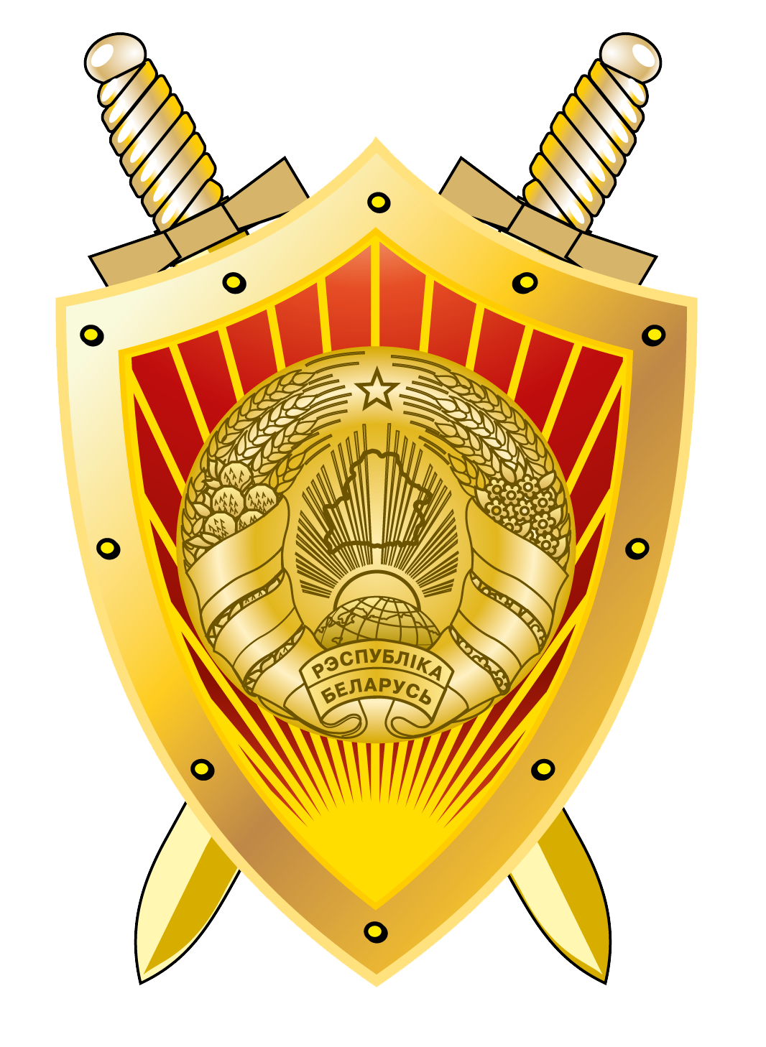
Prosecutor General’s Office of the Republic of Belarus

DRAFT PROGRAMME OF THE REGIONAL CONFERENCE OF THE INTERNATIONAL ASSOCIATION OF PROSECUTORS

“INTERNATIONAL COOPERATION ON COMBATING CRIME IN THE ERA OF GLOBAL DIGITALIZATION OF SOCIETY”
(MINSK, 3-6 June 2019)

3 June (Monday)

In the course of day | Arrival and accommodation of conference participants in the President-Hotel (Kirova street, 18)
18:30 – 21:00 | Standing reception in Olympus Hall of the President-Hotel

4 June (Tuesday)

9:00 – 9:30 | Registration of participants  Coffee service
9:30 – 9:40 | Press scrum
9:40 – 10:50 | Opening of the Conference:  - Alexander Konyuk, Prosecutor General of the Republic of Belarus;  - Gerhard Jarosch, President of the International Association of Prosecutors;  - Valentin Sukalo, Chairman of the Supreme Court of the Republic of Belarus;  - Valery Mitskevich, Deputy Head of the Administration of the President of the Republic of Belarus;  - Ivan Noskevich, Chairman of the Investigative Committee of the Republic of Belarus;  - Gary Balch, General Counsel of the International Association of Prosecutors  Cancellation of special stamp - postal project
10.50 | Collective photo
11:00 – 11:20 | Coffee-break
11:20 – 13:00 | Plenary 1: Cyber-terrorism – Threat to National Security. Ensuring the Protection of Objects of State and Social Infrastructure  Moderator:  - Kamran Aliyev, Deputy Prosecutor General, Director of the Anticorruption Directorate under the Prosecutor General of the Republic of Azerbaijan, IAP Vice-president  Speakers:  - Kamran Aliyev, Deputy Prosecutor General, Director of the Anticorruption Directorate Near the Prosecutor General of the Republic of Azerbaijan, IAP Vice-president.  “Combatting cyberterrorism – case of Azerbaijan”  - Oksana Kapinus, Rector of the University of the Prosecutor's Office of the Russian Federation, Doctor of Law, professor. “Foreign experience of combatting terrorism- and extremism-related crime using information telecommunication technologies”  - Azamat Razikov, Deputy Head of the Department for Adoption of Information and Communications Technology and Data Protection of the Prosecutor General’s Office of the Republic of Uzbekistan.  “Experience of the Republic of Uzbekistan in counteracting cyberterrorism and ensuring critical infrastructure objects security”.  - Dmitriy Perevalov, Leading research officer of the Special Department at the Institute of National Security of the Republic of Belarus, PhD in Law, Associate professor.  “Organizational and legal challenges of ensuring safety and security of critical objects under current conditions”. Presentation  - Natalya Moroz, Head of the Department of International Law at the International University (MITSO), PhD in Law, Associate professor.  “Regionalization of international and legal cooperation in combating cybercrime”. Presentation
13:00 - 14.30 | Lunch in the “Stolitsa” Restaurant, President-Hotel
14.30 – 16:00 | Plenary 2: Protection of Personal Data and Combating Cybercrime: Examples of National Experiences  Moderator:  - Andrei Maltsev, Head of the Department for Supervision over Law Compliance and Legality of Legal Acts of the Prosecutor General’s Office of the Republic of Belarus  Speakers:  - Andrew Richardson, Procurator Fiscal, High Court Division, Crown Office and Procurator Fiscal Service, Scotland.  “The use of electronic evidence and respect for human rights”  - Russell Tyner, Specialist Prosecutor on Cybercrime, Organized Crime Division, Crown Prosecution Service, England and Wales. “Personal data protection and fight against cybercrime: examples of national experience”  - Arthur Zavalunov, Head of the Legal Department of the Prosecutor General’s Office of the Russian Federation.  “Legal mechanisms of countering current cybercrime threats and personal data protection”. Presentation  - Vadim Ipatov, Director of the National Centre for Legislation and Legal Research.  “Improvement of legal regulation of personal data protection in the Republic of Belarus”
16:00 – 17:00 | Free time
18:30 | Official dinner (according to delegation programs)
5 June (Wednesday)

9.30 - 11.00 | Plenary 3: Modern Procedures for Collecting Electronic Evidence in Terrorism and Organized Crime Investigations and Prosecutions  Moderator:  - Gennadiy Dysko, Deputy Prosecutor General of the Republic of Belarus  Speakers:  - Marat Akhmetzhanov, Deputy Prosecutor General of the Republic of Kazakhstan.  “On the introduction of digital technologies in law enforcement activities in Kazakhstan”. Presentation  - Ilya Tarasov, Senior Prosecutor of the Division for Supervision over Operational-Search Activities of the Prosecutor General’s Office of the Russian Federation.  “The specifics of organizing prosecutor's supervision over the execution of legislation concerning investigative activities in the area of international cooperation on countering crime in the era of global digitalization of society”  - Aleksey Kholopov, Head of the Forensics Lab at the Saint-Petersburg Law Institute (branch) of the University of the Prosecutor's Office of the Russian Federation.  “Technical means and methods of digital forensics”  - Kirill Vyatkin, Deputy Head of the High Tech Crime Detection Unit of the Ministry for Internal Affairs of the Republic of Belarus. “Transboundary character of cybercrime”. Presentation.
11.00 - 11.30 | Coffee-break
11.30 - 12.30 | Conference continues  - Dmitriy Uloga, Justice of the Supreme Court of the Republic of Belarus.  “On the practice of court trial of criminal cases regarding crimes against information security”  - Olga Zudova, International Consultant, UN Office on Drugs and Crime.  “Practical considerations of requesting electronic evidence from foreign states”  - Miroslava Krasnoborova, Liaison Prosecutor for Ukraine at Eurojust, member of the Eurojust Cybercrime Team.  “Eurojust: opportunities and instruments”.
12.30 - 13.00 | Closing Session  Speakers:  -Alexander Konyuk, Prosecutor General of the Republic of Belarus;  -Han Moraal, Secretary General of the International Association of Prosecutors
13.30 - 15.00 | Lunch in the “Stolitsa” Restaurant, President-Hotel
15.00 - 17.00 | Free time
18.30 - 21.00 | Farewell reception in “Robinson Club Restaurant” (White Hall)
6 June (Thursday)

In the course  of day | Departure of conference participants

